Batch Legacy
- NITT UG Research Fellowships/Scholarships by the Class of 1974 and Dr. Ram and Thaila Foundation
The Class of 1974 and Dr. Ram and Thaila Foundation have embarked on a visionary 10-year initiative to elevate research activities at NIT Trichy. This initiative provides substantial support to selected research proposals, including full funding of ₹90,000, up to ₹15,000 for approved research materials, and ₹20,000 Merit Certificate Awards. These contributions not only nurture innovative thinking among students but also recognize and reward their scholarly achievements.
- Nobel Laureate Visit Funded by the Class of 1980
The Class of 1980 has established the Eighty Batch Chair Fund (EBCF) with a generous contribution of one crore rupees to facilitate visits from Nobel Laureates. This fund has enabled distinguished figures like Nobel Laureate Dr. Richard John Robert, renowned for his groundbreaking work on split genes, to visit NIT Trichy. Dr. Robert's presence during Pragyan 2024 enriched the academic environment, inspiring students and faculty alike with his profound insights and experiences. The EBCF continues to enhance NIT Trichy's reputation as a hub of intellectual discourse and innovation in the field of science and technology.

1978 Batch – Endowment & Scholarship
The 1978 Batch strengthened its legacy of giving by creating a new EWS Endowment of ₹46 lakhs in 2024, building upon its earlier endowment established in 2018. With this addition, the total contribution of the batch has reached ₹1 crore.
Scholarship disbursements included:
- 6 students receiving ₹40,157 each under the 1978 Scholarship
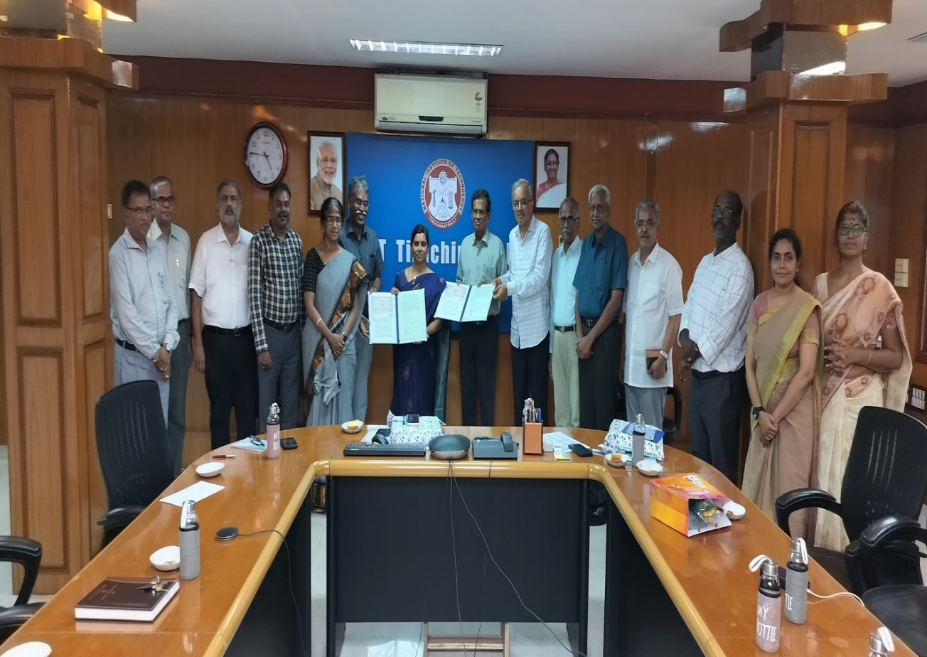
- 2 students receiving ₹20,833 each under the 1978 EWS Scholarship

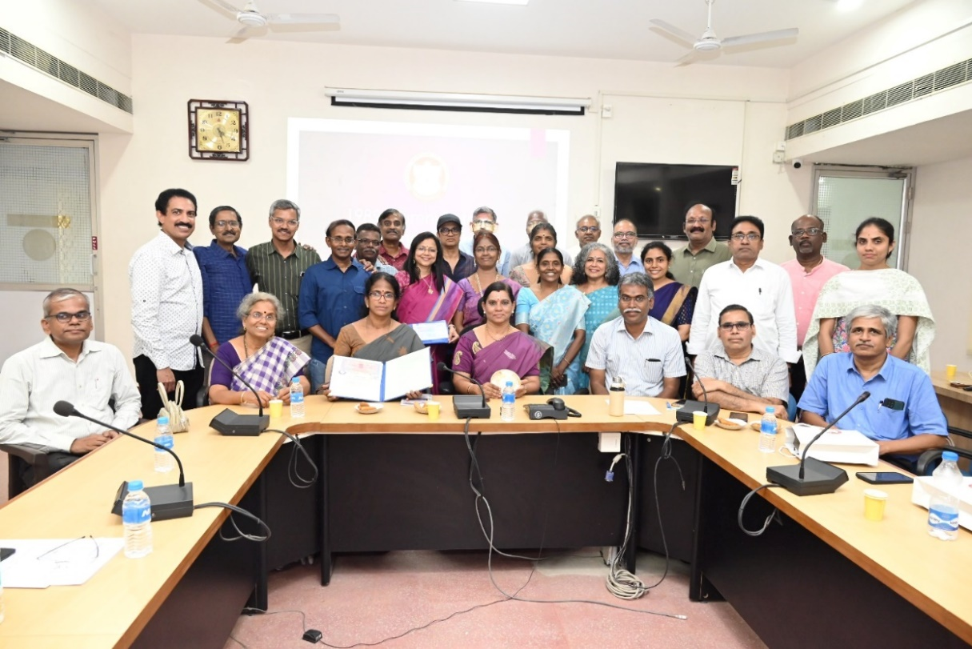
RECT 1989 Student Aid Fund – ₹1.5 Crore Endowment

The 1985–1989 Batch established the RECT 1989 Student Aid Fund, creating a ₹1.5 crore endowment, the largest batch contribution to date. Formalized through an MoU signed in the Senate Hall in the presence of the Director and Deans, this fund supports economically disadvantaged students by covering tuition, hostel, and institutional fees. During the year, ₹7,86,434 was disbursed to 6 students as per approved norms.
IoT & UAV Research Lab funded by the 1999 CSE Batch – ₹50 lakhs
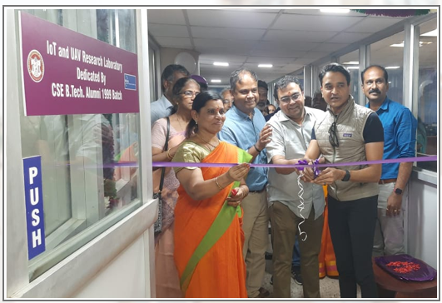
Key contributions include the establishment of the IoT & UAV Research Laboratory in the Department of Computer Science and Engineering, supported by the 1999 CSE Batch alumni with a contribution of ₹50 lakhs. The facility provides an advanced platform for interdisciplinary research and hands-on learning in emerging technologies such as Internet of Things, autonomous drones, sensors, and communication systems, enabling students and researchers to work on real-world applications and innovation-driven projects.
SCIEnT Centre inaugurated by 1990 Batch – Fostering tech innovation

